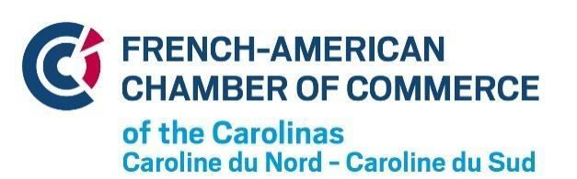

2021 Annual Membership Levels & Benefits
Please indicate your desired membership level

Membership levels | Individuals |  |  | Companies and Organizations
 | Student VIE | Classic | Supporter | Small Business | Corporate | Patron | Partner
 | $30 | $75 | $250 | min $500 | min. $1,250 | min. $2,000 | min. $3,000
Number of Member Representatives | 1 | 1 | 1 | 1 | 3 | 4 | 5
Event registration at preferential rate | ✓ | ✓ | ✓ | ✓ | ✓ | ✓ | ✓
Number of event guests at preferential rate | 1 | 1 | 1 | 2 | 5 | 10 | 20
French VAT refund |  |  |  | ✓ | ✓ | ✓ | ✓
Access to J-1 Visas / VIE Program |  |  |  | ✓ | ✓ | ✓ | ✓
Inclusion of your logo on our website |  |  |  | ✓ | ✓ | ✓ | ✓
Promotional article(s) in our newsletter and on our website |  |  |  | 1 | 2 | 5 | 5
Promotional post on our social media platforms |  |  |  | 3 | 5 | 10 | 20
Inclusion of your logo in our newsletter |  |  |  |  | ✓ | ✓ | ✓
Email-blast(s)on your behalf to our database contacts |  |  |  |  |  | 1 | 3
Exclusive event to promote your organization |  |  |  |  |  | ✓ | ✓
One seat on the FACCC Board |  |  |  |  |  |  | ✓

APPLICATION INFORMATION

Company name:
Address
Primary contact (name, title, email address, phone)
Other contacts:

Website |  | Phone

I agree to share my contact information with other FACCC members on the private members’ portal on the FACCC website. Circle the correct answer. | Yes | No

PAYMENT INFORMATION

❑ Visa | ❑ Master Card |  | ❑ American Express
Amount: |  | CC Number:
CVV Code: |  | Expiration Date:
Name on Card: |  | Printed Name:
Billing Address: |  | Signature and Date:
Check ❑ Send your payment to FACCC
Paypal ❑ Send your payment to info@facccarolinas.com through www.paypal.com
Please return your application to info@facccarolinas.com or by mail to
FACCC - Maison de France - 5512 Munford road - Raleigh, NC 27612
If you have questions, contact Marie-Claire Ribeill, FACCC Executive Director
(919-413-8481, exec.dir@faccCarolinas.com)
Thank you for your support, we look forward to seeing you at our events!

